**Genii Analytics | General | Information Guide**

V1. October 2020

Contents

Lists 2

Calculations 3

General 4

Comparing Views 6

Fault finding 8

1. Summary: Local IT need to open proxy 8

# Lists

When updating any list in the list management or Form Wizard feature the following need to be taken into consideration.

1. Each List box will only accommodate 8 000 characters, this includes any commas, spaces, carriage returns and special characters.

If your list has a greater character count, you can add another list box with the same name.

1. Semi-Colons (;) are the standard delimiter in these fields, however the following will also act as a delimiter so ensure that it is not part of your list items.

Comma (,)

Colon (:)

# Calculations

AQA

Sentiment (set in the Section Portion of the Questions)

Failures – where the greater than sign (>) is allocated to an assessment.

1. Negative = Failures / Total Assessments
2. Positive = 1- (Failures / Total Assessments)

Smart

Here the Passes are indicated with the greater than sign (>)

Scenario:

If you have 10 questions with 10% weight each and you pass 9 and 1 is N/A your total weight is 90% but your score is 100%

We measure the capture form as a score card with a total of 100, we see this as a score.

If the assessor gives an assessment a N/A answer with the clauses specified above. The score total will become 90.

Thus, the calculation will look like as follows [PositiveScore]/[TotalScore] * 100.

This calculation will be represented as follows 90/90*100 = 100%

Where the first 90 is the score and the second 90 is the total thus the assessments will still score 100%

N/A can be a pass (if > is added) but can never be a failure as the code excluded it.

# General

1. When doing a capture:

When adding a number greater than four characters to the any comment box, the number will be replaced with XXXX.

This is to ensure that no contact numbers or account numbers are saved as per legislative.

Only the System reference box is exempt from this validation.

1. Coach Status: coaching completed vs coaching started
2. Coaching completed columns will update if the LAST feedback given per assessment is Completed.
3. Character length for comment box

System ref: 250

Comment box: 990

List box: 8000

1. If the following is entered < *TEXT* > into any comment box and error will occur.
2. Hold for UserDefined04 should be entered in the following format to ensure that it displays on CDM mm:ss (01:23) or m:ss (1:23).
3. For CSAT your section must be name *Voice of the Customer* to display on CDM. Any failures will attribute to score regards of wording.
4. CDM only shows the top 15 call reasons.
5. SMART & Weighted AQA - Assessment Target – what weight (score) needs to be achieved to pass the assessment. Assessment Scope
6. SMART & AQA – Pass Target – the % Assessments that have reached the Assessment Target. Campaign Scope.
7. Criteria not Met is based on the Assessment Target.
8. Assessor Efficiency Percentage = Interaction duration / Action duration

Action Duration = Submit Assessment time – Start Assessment time

Interaction Duration = Time added to the as the duration of the call on the Call Details page (The length of the call)

1. When you assign a user to a customer only the campaigns in RUN status will be available on the Assessment Capture Form page

Comparing Views

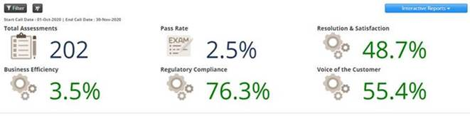

The dashboard indicates the accuracy by section, i.e. total number of passes without fail by section, the calculations will be as follows:

|  |  |  |
| --- | --- | --- |
| **Section:** | **Calculation:** | **Comments:** |
| Resolution & Satisfaction | # of evaluations with no RESOLUTION & SATISFACTION errors / total # of evaluations | This is the score for the section only |
| Business Efficiency | # of evaluations with no BUSINESS EFFICIENCY errors / total # of evaluations | This is the score for the section only |
| Regulatory Compliance | # of evaluations with no REGULATORY COMPLIANCE errors / total # of evaluations | This is the score for the section only |
| Voice of the Customer | # of evaluations with no VOICE OF THE CUSTOMER errors / total # of evaluations | This is the score for the section only |
| Pass Rate | # of evaluations with no ERRORS / total # of evaluations | This is for the overall evaluation |

The Root Cause tree is independent from Accuracy measures. The Root Cause tree is a distribution of failures or insights.

The best would always be to filter by Performance Metrics Sections or BI, so in the example below, first filter just for Resolution & Satisfaction, Business Efficiency, Regulatory Compliance & Voice of the Customer. Once filtered this will show you the section with the biggest failure rate, i.e. using the example below, (and hypothetically if Business Intelligences was not included), 45% of failures were identified in the Business Efficiency section. So basically it is saying if there are 200 assessments, and of those 200 assessments, 120 were failures and 80 were passes, it would only look at the 120 failures and shows you how those 120 failures are distributed. This is done to indicate where the biggest opportunity is to improve results. So technically yes, if the Pass Rate is 2% then the Insights Distribution shows you the 98% of failures as a distribution of a 100% across all the sections.

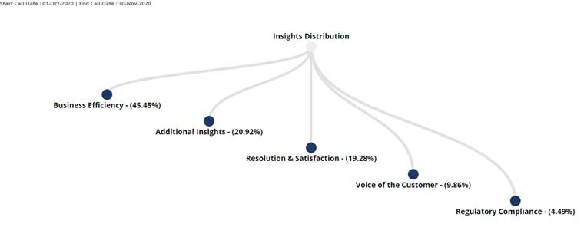

# Fault finding

1. Summary: Local IT need to open proxy

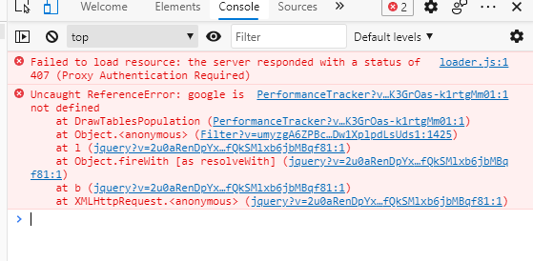

*Genii IT*

*You are getting a 407 error that is being returned by your company's proxy server.*

*We do not pass on any client information onwards, so this means that our system will not pass on your windows authentication details to the proxy so that it will authenticate the request properly.*

*The URL being requested can be seen by pressing F12 and going to network there will be a line with a status code of 407. This is the server request being blocked by your company's proxy.*

*I suspect this problem is when the client-side code requests code from google, via* [*www.gstatic.com*](http://www.gstatic.com)*that it is blocked on your side. This code that we obtain from* [*www.gstatic.com*](http://www.gstatic.com)*is primarily used for charts.*

*Can you please ask your local IT and infrastructure engineers to investigate the possibility of opening this URL for yourself and all other effected on your proxy?*